**ARDUINO BOTICS**

Attending a 2-day Arduino robotics workshop at the College of Engineering, Guindy, was an enriching experience that provided hands-on learning opportunities in building various robotic applications. Throughout the workshop, participants gained valuable insights into the principles of robotics and honed their skills in utilizing Arduino microcontrollers, motor drivers, chassis, and sensors to develop functional robots.

The workshop curriculum encompassed a diverse range of topics, with a particular focus on designing and implementing three key robotic functionalities: line following, obstacle avoidance, and voice control. Participants were guided through the step-by-step process of assembling robot hardware components, including motors, wheels, sensors, and microcontrollers.

In the line follower module, attendees learned the fundamentals of sensor-based navigation and programmed their robots to follow predefined paths using infrared or color sensors. This exercise enabled participants to understand the concept of feedback control and implement algorithms for line tracking.

The obstacle avoidance segment delved into techniques for detecting and circumventing obstacles in the robot's path. Through practical exercises, participants gained insights into sensor integration and decision-making algorithms, empowering them to create robots capable of navigating complex environments autonomously.

The highlight of the workshop was the voice control module, where participants explored the integration of voice recognition modules with Arduino microcontrollers. By leveraging speech recognition algorithms and command parsing techniques, attendees learned to develop robots capable of responding to voice commands, opening up possibilities for intuitive human-robot interaction.

Hands-on sessions were complemented by interactive lectures, demonstrations, and troubleshooting sessions, fostering a dynamic learning environment conducive to experimentation and innovation. Moreover, collaborative activities and team challenges encouraged participants to apply their newfound knowledge creatively, fostering teamwork and problem-solving skills.

**CODE:**

void setup()

{

pinMode( 8 , INPUT);

pinMode( 9 , INPUT);

pinMode( 10 , OUTPUT);

pinMode( 11 , OUTPUT);

pinMode( 12 , OUTPUT);

pinMode( 13 , OUTPUT);

}

void loop()

{

if (digitalRead( 8))

{

digitalWrite( 13 , HIGH );

digitalWrite( 12 , LOW );

}

else

{

digitalWrite( 13 , LOW );

digitalWrite( 12 , LOW );

}

if (digitalRead( 9))

{

digitalWrite( 11 , HIGH );

digitalWrite( 10 , LOW );

}

else

{

digitalWrite( 11 , LOW );

digitalWrite( 10 , LOW );

}

}

The above code we will used for the Line follower Robot for the Workshop

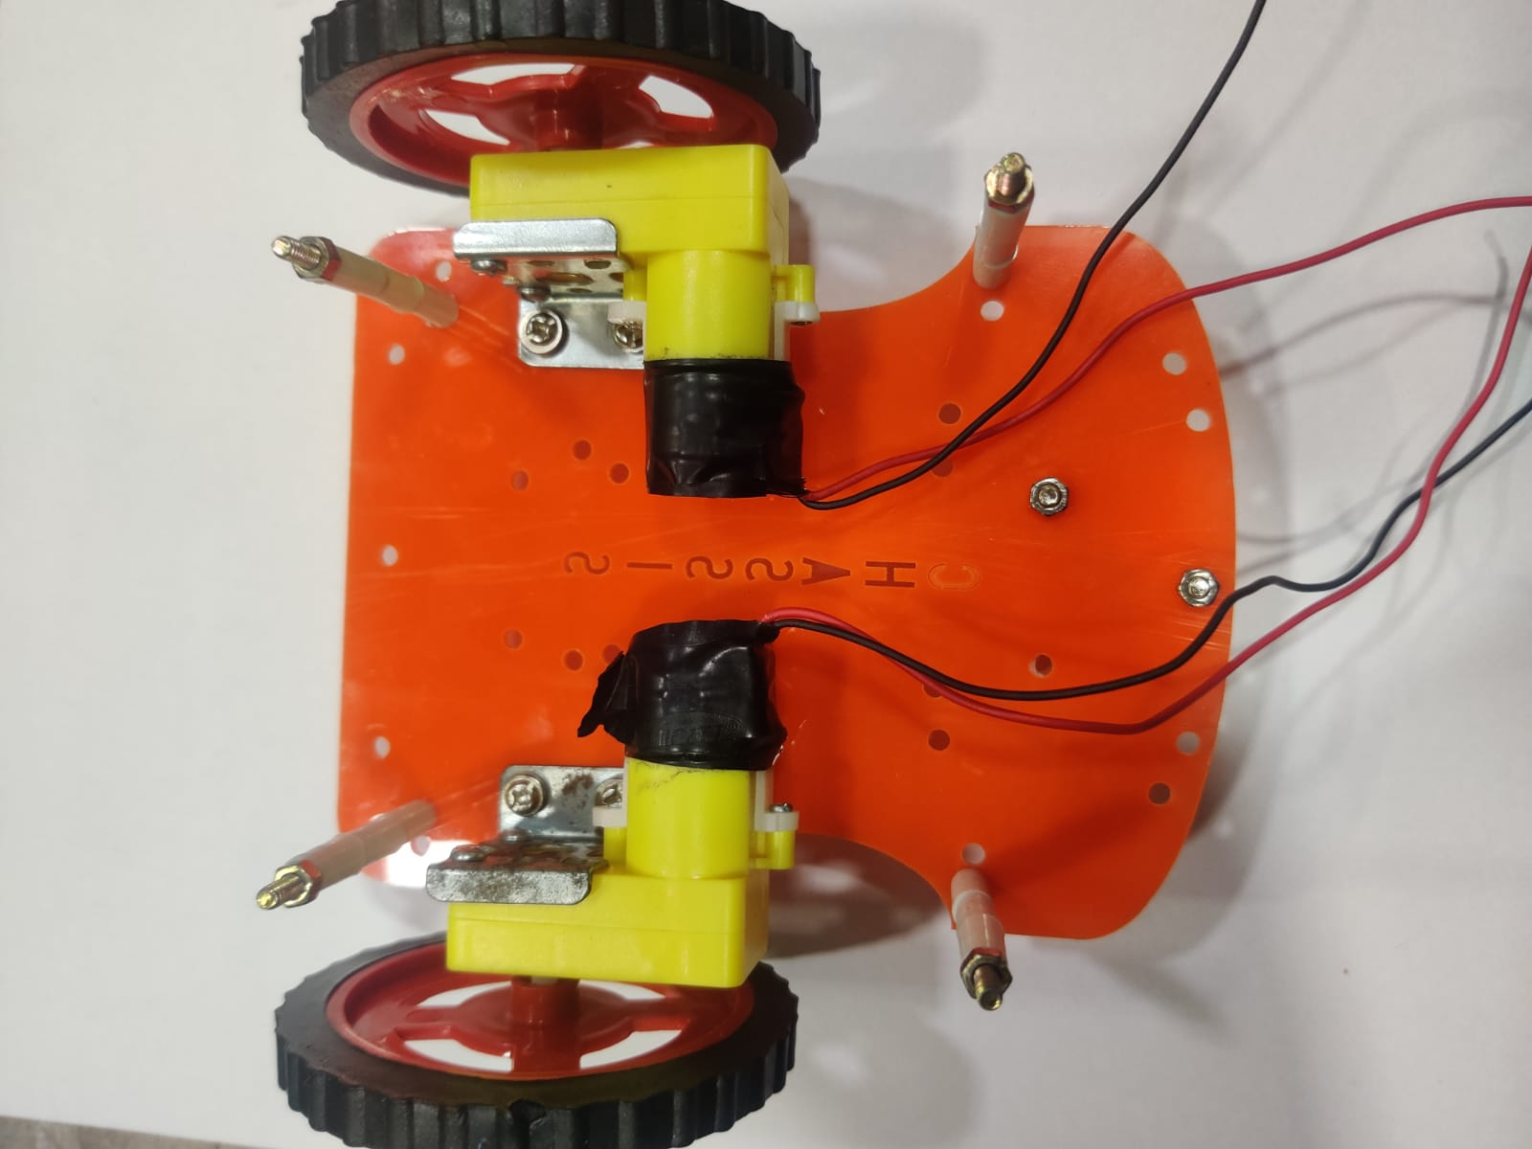

The robot chasis and motor connection we have made

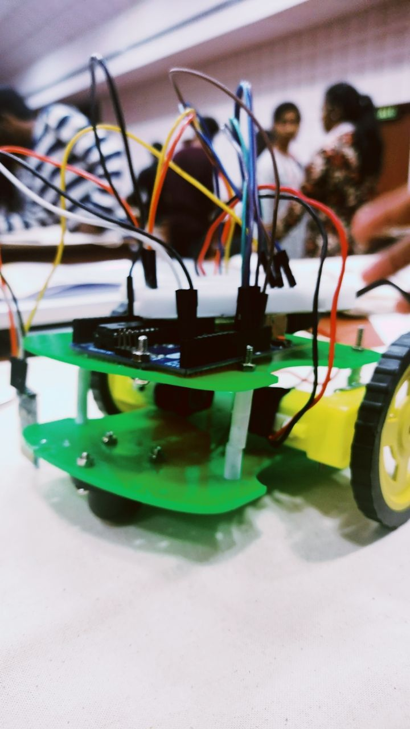

This is the robot we have designed